26.93: a) The circuit can be re-drawn as follows:
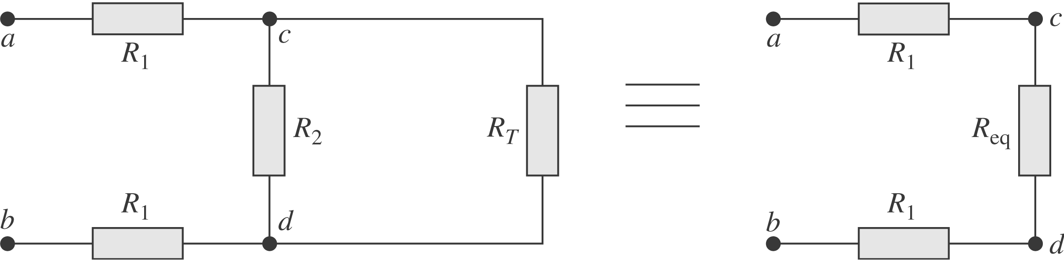
Then 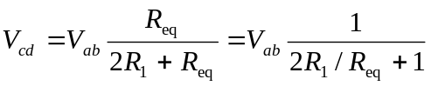 and 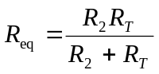.
But 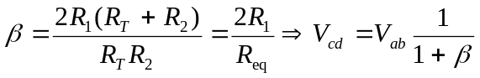.
b) Recall 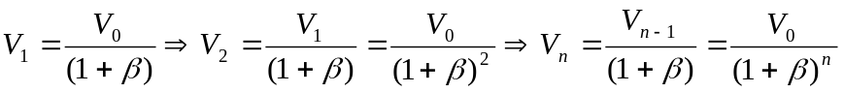.
If and 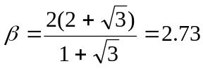. So, for the nth segment to have 1% of the original voltage, we need:
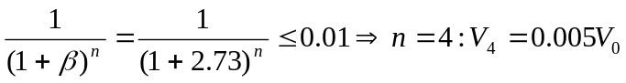.

c) 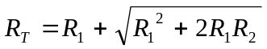
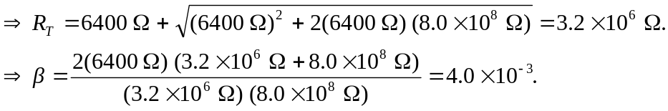

d) Along a length of 2.0 mm of axon, there are 2000 segments each 1.0  long. The voltage therefore attenuates by:
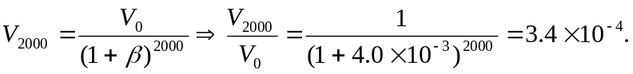

e) If and 